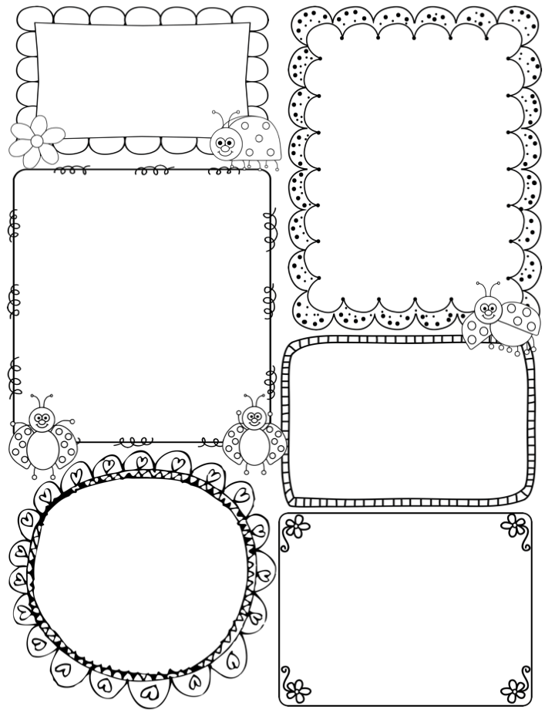

Diary Dates
wb 2nd February- settling in phone calls new children
Friday 13th February
Close for half term break
Monday 23rd February
Children Return
Thursday 5th March
World Book Day 2026 – bring your favourite book and you can dress up!
Tuesday 10th March –Mum’s Stay and Play afternoon 2pm - 3pm
Friday 20th March – Red Nose Day wear Red
wb 23rd March – phone call updates all children
Thursday 2nd April – Close for Easter break no pm crèche close at 12.30pm
Tuesday 21st April
Children back for Summer Term

What will the children will be learning this term?

Spring is a fantastic season for learning about the natural world!
We will walk around school looking for ‘Signs of Spring’.
Our core books this term are The Gruffolo and
The Ginger Bread Man

Welcome!

A very warm welcome to all our new families. We hope your child is enjoying their first few weeks at Nursery. We are positive everyone at nursery will have an amazing Spring Term and have lots of fun!

Communication - Please check your emails regularly as we use ‘Arbor’ frequently to keep you all updated.

-Look out for an email regarding a parent survey which shall be emailed to you all soon!

POLITE REMINDERS:
-We have many children with allergies – we are a nut free school no peanut butter or chocolate spread.
-Please do not use mobile phones in school.
-We go outside in all weather, so a named warm coat, scarf and gloves would be great.
- Please do not use the staff car park.

Scartho Nursery School
Newsletter
Spring Term 2026
872129
office@scarthonursery.co.uk
A great big THANK YOU to staff, governors, parents and the wider community for supporting the Christmas raffle by donating prizes and buying tickets.

You should all be able to access ‘Tapestry’ which is our online journal.
If you haven’t, please let us know!

